ENGN6528

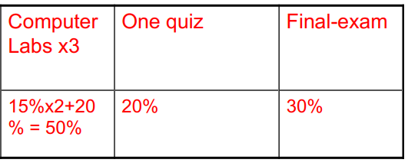

MATH6005

* 10 assignments (10% in total: LO 1-4)
* Mid-semester test (30%; LO1-4)
* Final examination (40%; LO 1-4)
* 1 project linking Mathematics to own field of interest (20% in total: LO 1-6)